[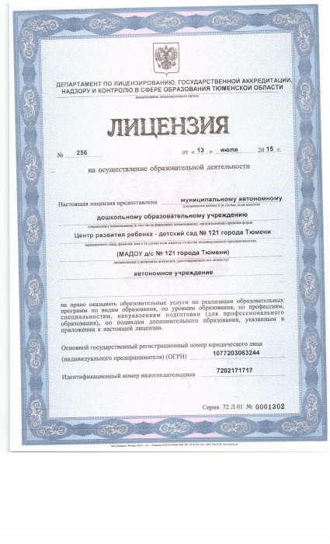](http://121сад.рф/wp-content/uploads/2014/10/Scan0001.jpg)

[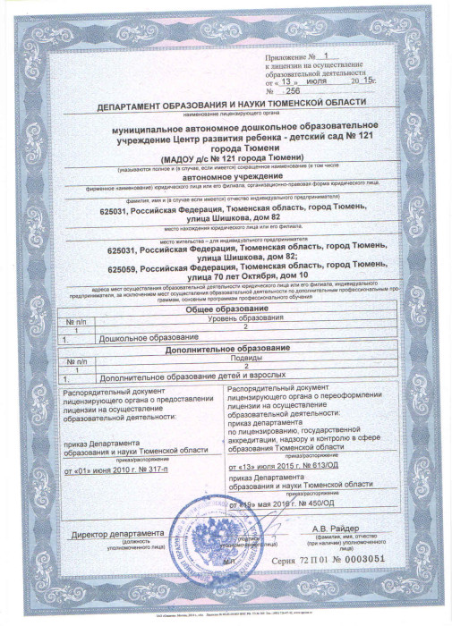](http://121сад.рф/wp-content/uploads/2014/10/lits1-1.jpg)

[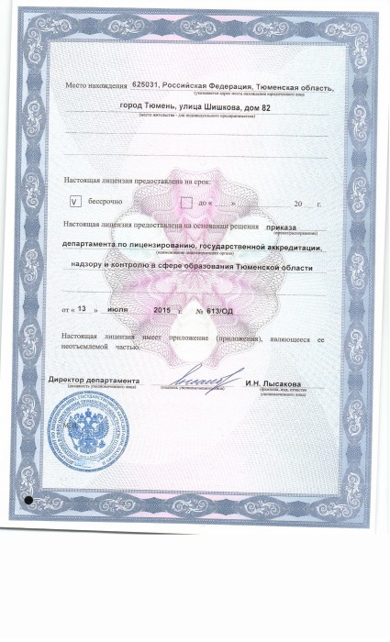](http://121сад.рф/wp-content/uploads/2014/10/Scan0003.jpg)